**Medicine Alert**

**and**

**Reminder System**

**(MARS)** 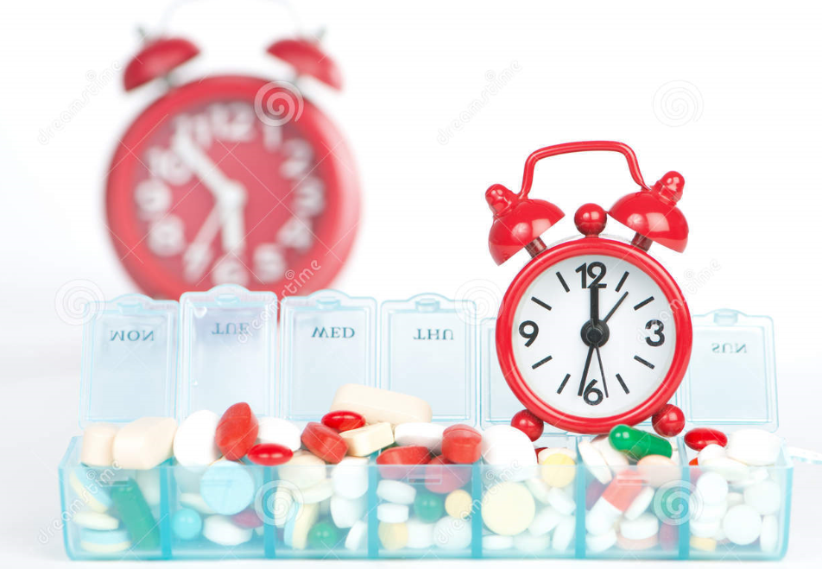

**Team Number: 16**

**Team Members:**

* Paresh Sudin Kasare - 39
* Harish Kolla - 44
* Sreeya Reddy Daripalli - 18
* Ravali Nalla - 59

**Table of Contents**

**Topic Page no**

**Introduction of MARS** 3

**Increment Objective** 4

**Features of Third Increment** 4

**Detailed Design Features** (Wireframes and UML) 5

**Updated Wireframes** 12

**Previous Implementations** 18

**Third Increment Implementation** 32

**Existing Services/API** 43

**Testing**  44

**Technology Used** 45

**Project Management** 46

**Bibliography** 47

**Introduction**

**Medicine Alert and Reminder System** is the system which provides the complete system for medicine management. It helps users to add their medicines with the recommended time and the app will remind to take medicines on specific time. If a medicine must have a minimum gap of hours, then app will remind of the next dosage of medicine after recommended gap between two dosages.

For more detailed information go through the Increment-I Documentation:

https://github.com/pareshkasare/ASE_Project/blob/master/Documentation/Increament-1%20Report.pdf

**Increment Objectives**

**OBJECTIVES:**

The main aim of this phase is to provide an overview of the project and the tasks that are completed till third increment.

**Features of Third Increment**

Features we are deploying are:

* Add notifications per day
* Display medicines
* Delete alarm manager in update activity
* Delete medicine
* Change medicine schedule
* Increase/Decrease medicine quantity

**Detailed Design Features (Wireframes & UML)**

**First Increment:**

**Login Wireframe:**

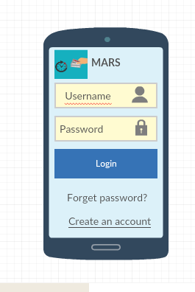

**Register Wireframe:**

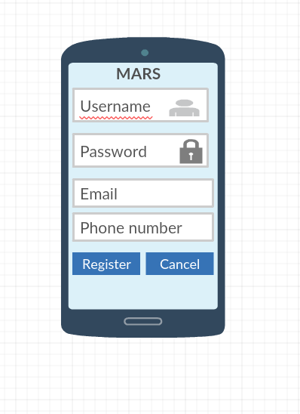

**Second Increment:**

**MainActivity Wireframe:**

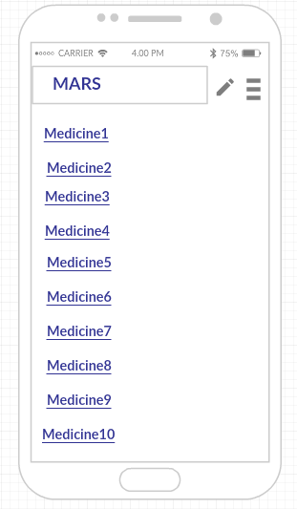

**AddActivity Wireframe:**

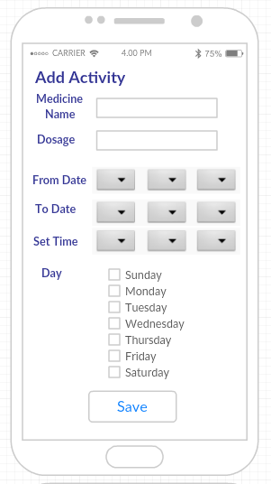

**UpdateActivity Wireframe:**

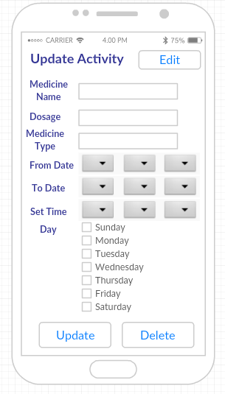

**NotificationActivity Wireframe:**

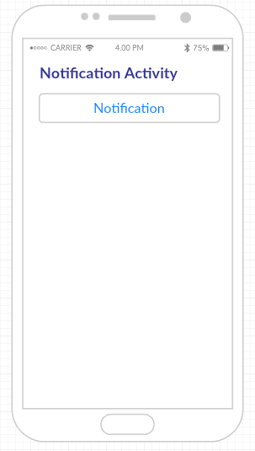

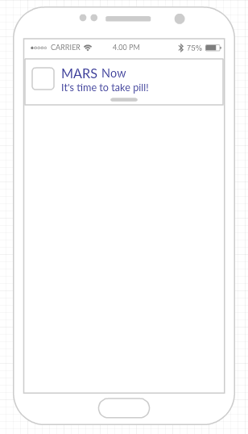

**Third Increment:**

**Updated the AddActivity and UpdateActivity Wireframes:**

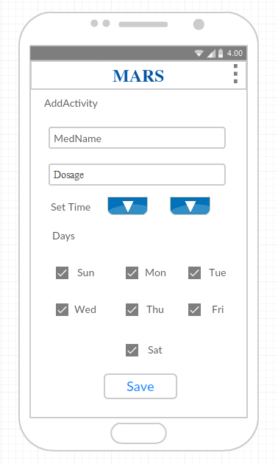

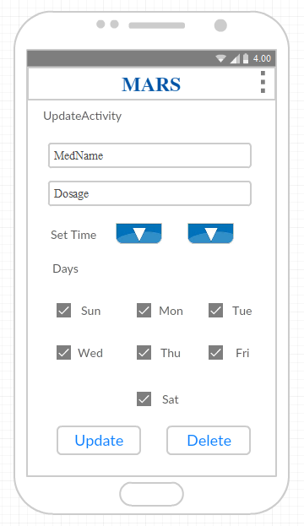

**First Increment(UML):**

**Class Diagram:**

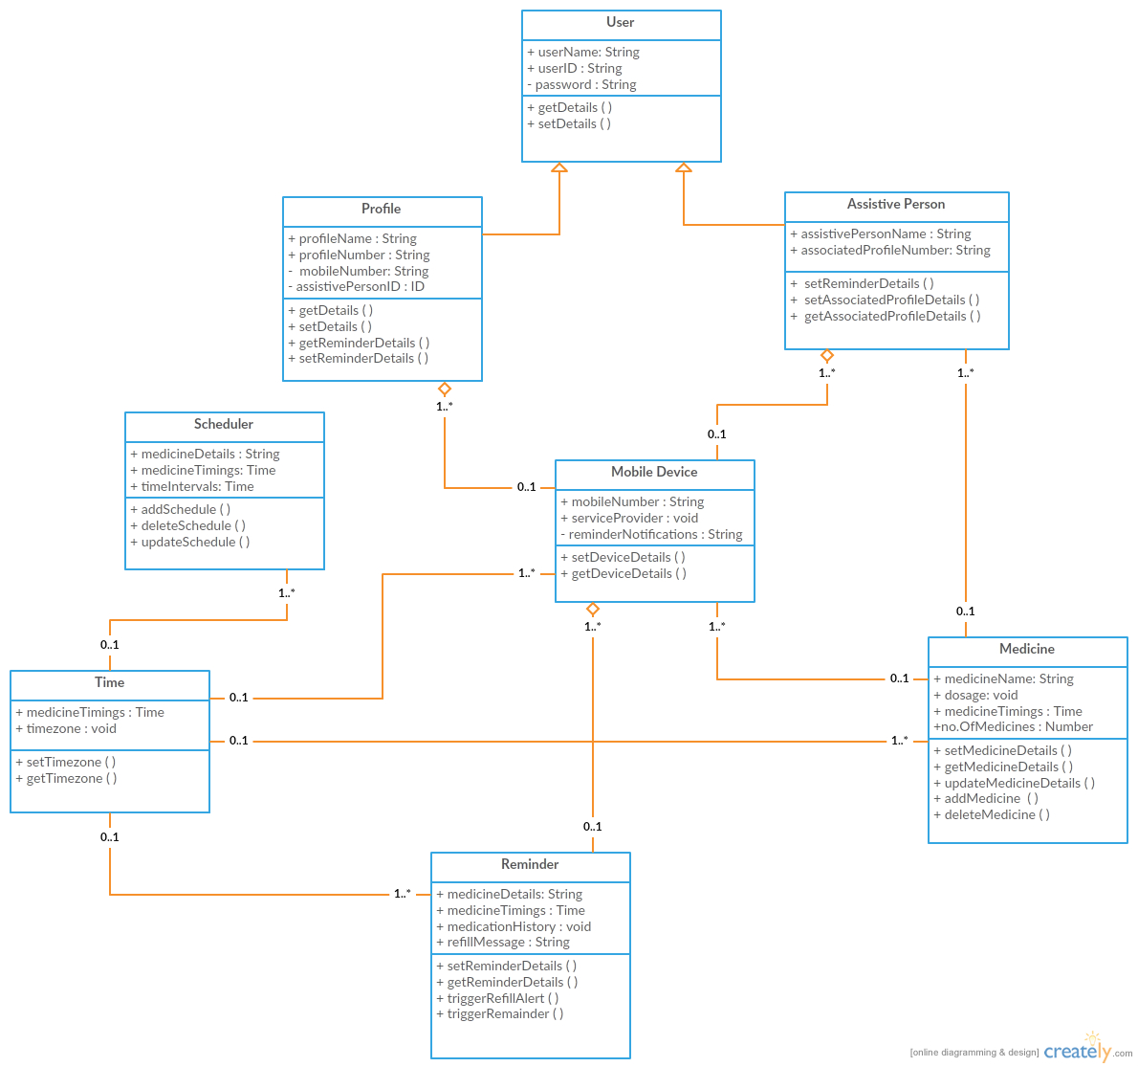

**Activity Diagram:**

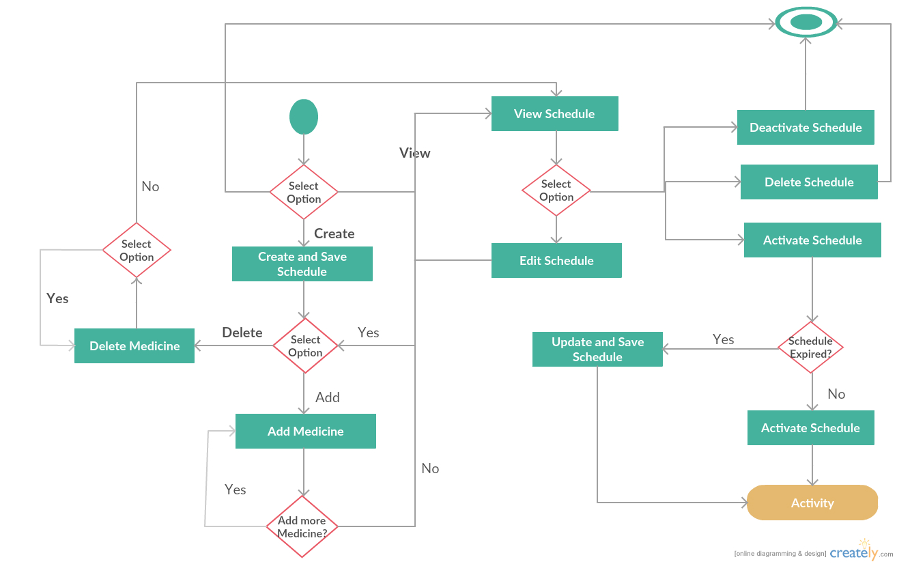

**Sequence Diagram:**

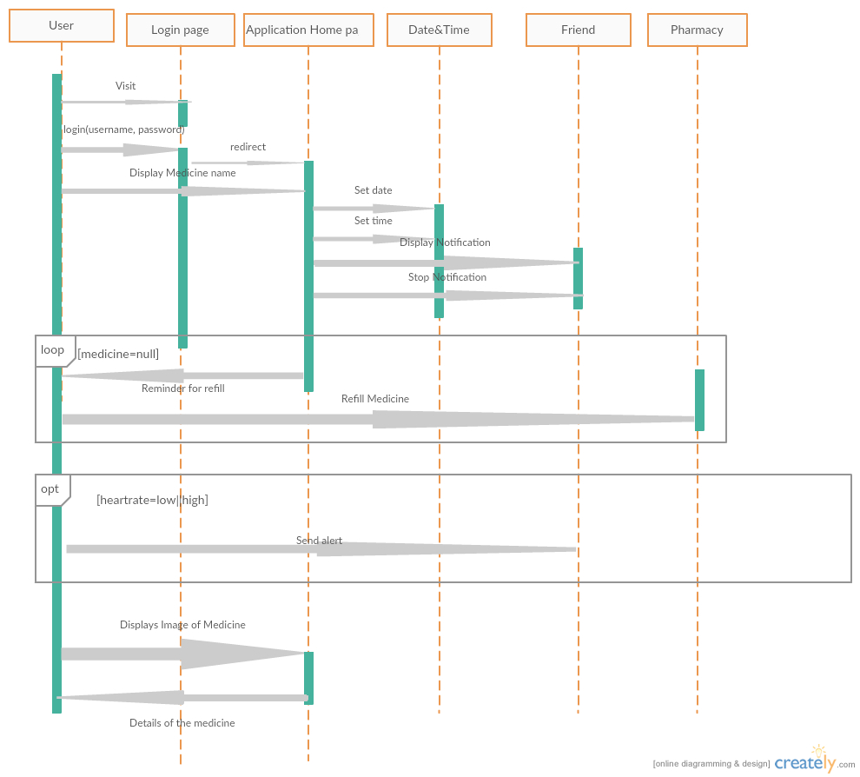

**Architecture Diagram:**

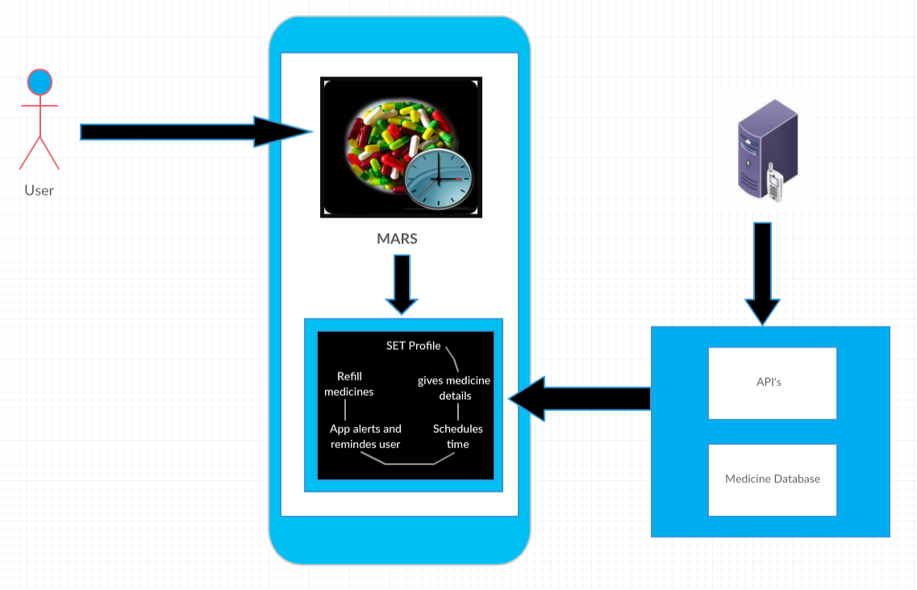

**Previous** **Implementations**

**Login Screen in Android:**

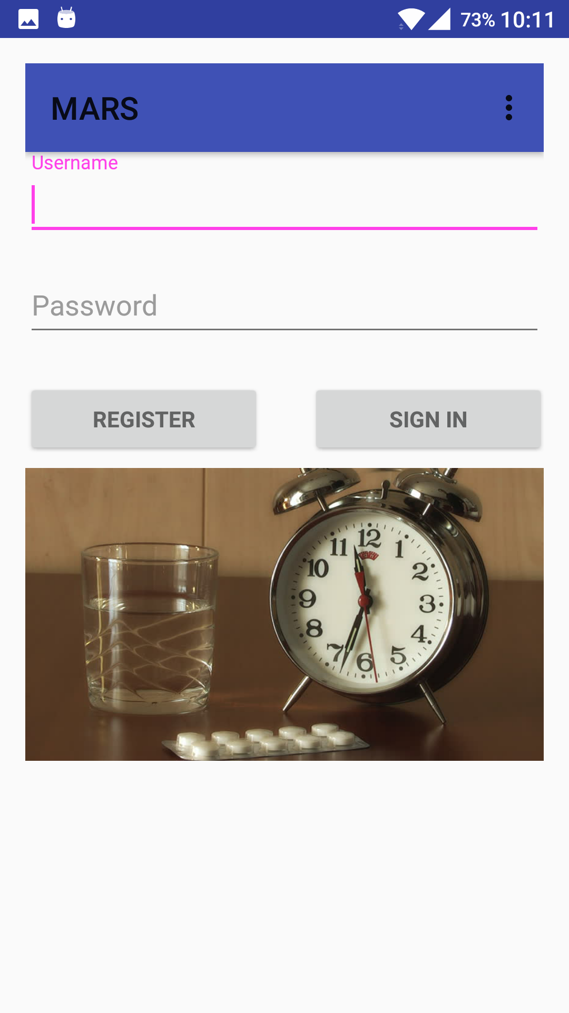

**Login Screen with Settings:**

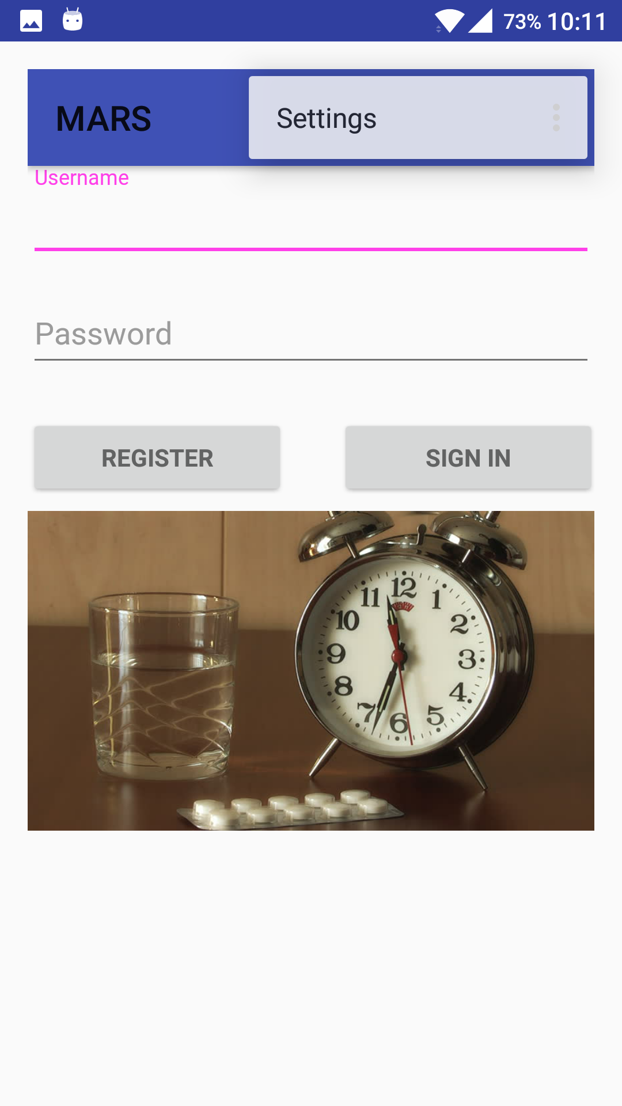

**Login Screen when NO username is entered:**

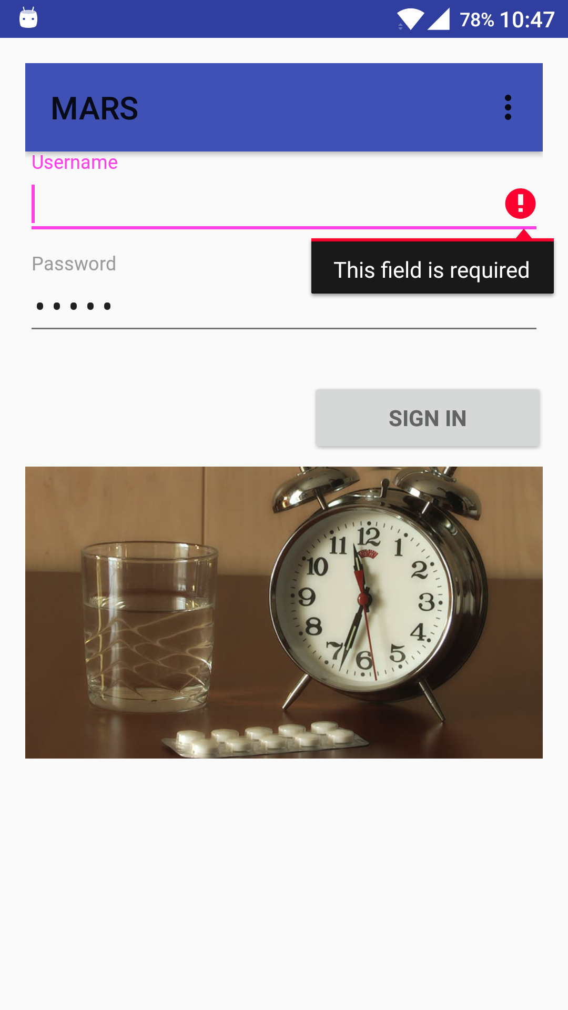

**Login Screen when password entered is incorrect:**

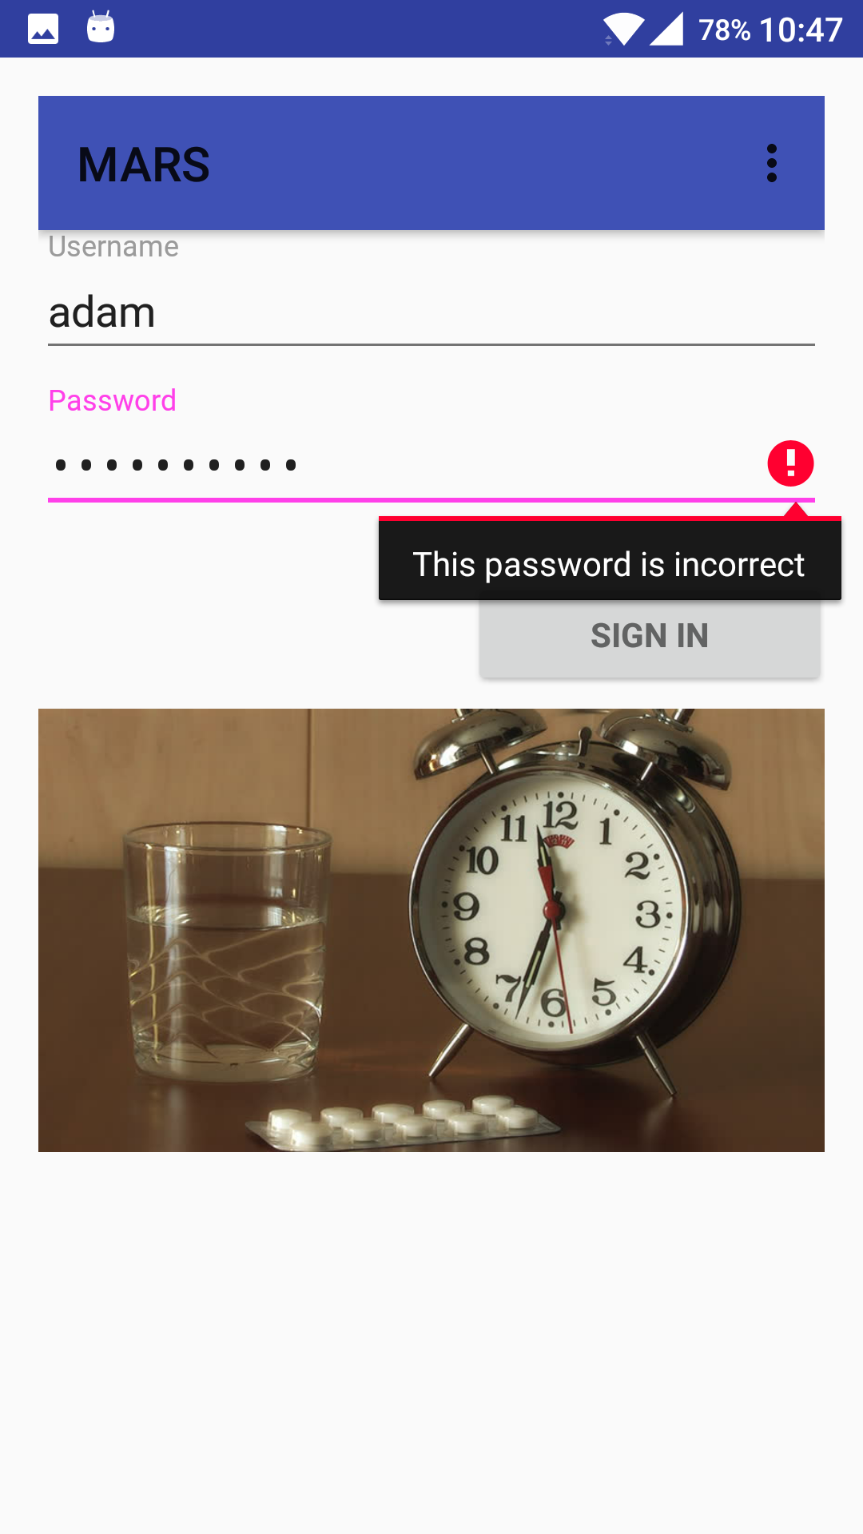

**Registration Screen in Android:**

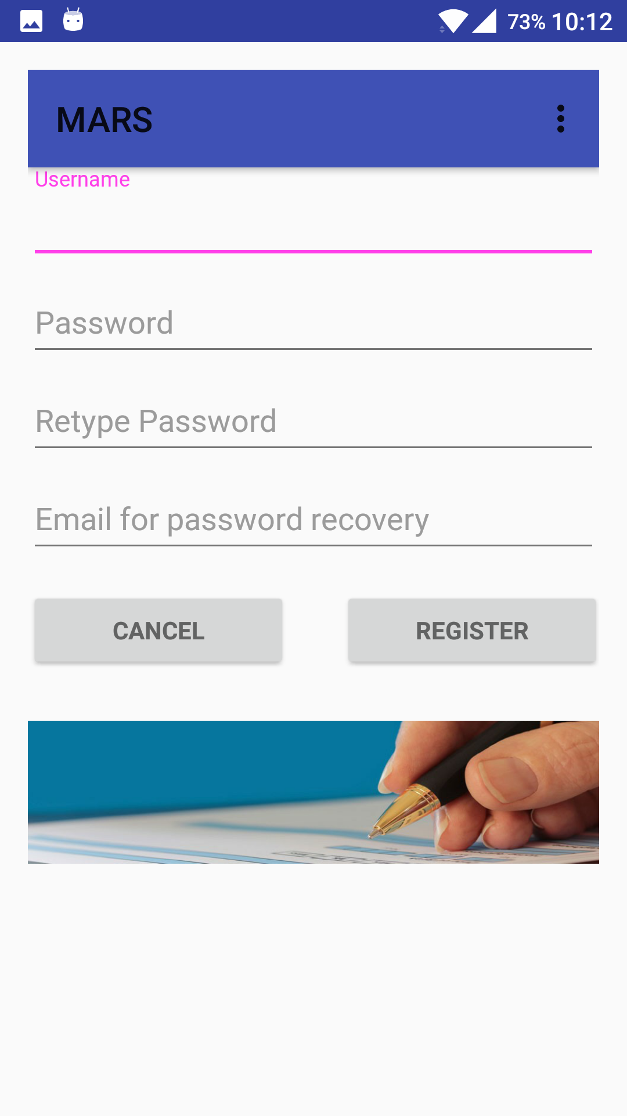

**Registration Screen when password is short:**

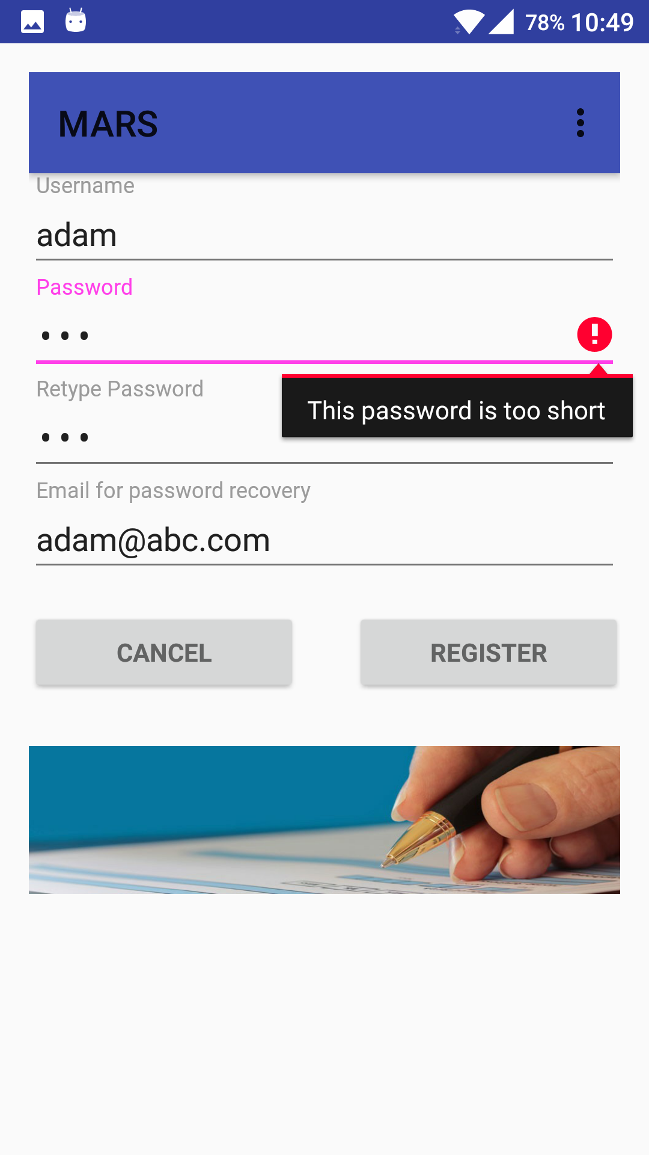

**Registration Screen when passwords don’t match:**

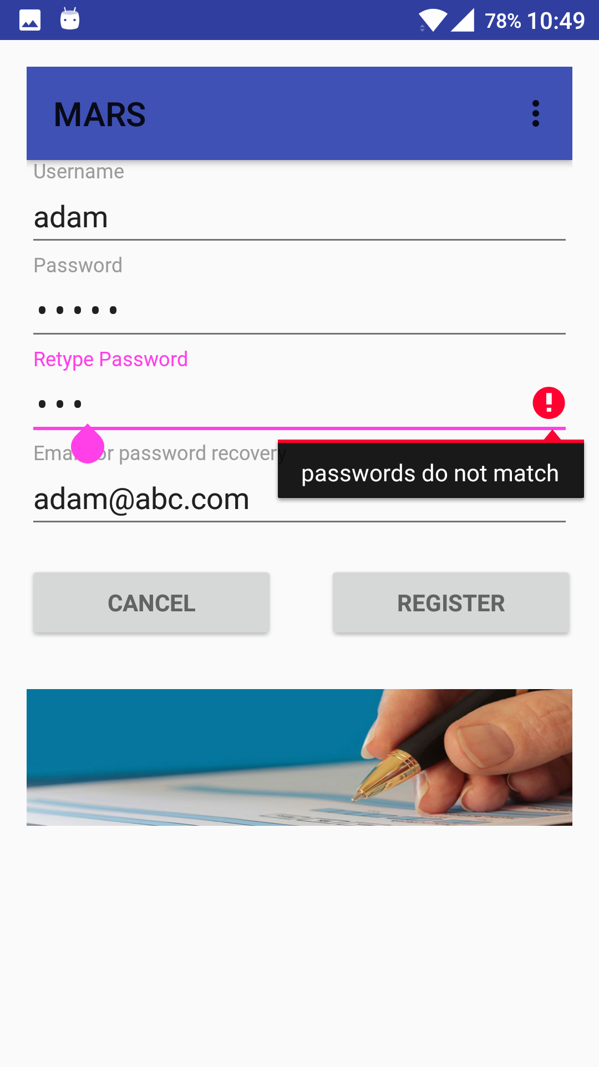

**Registration Screen with email for password recovery:**

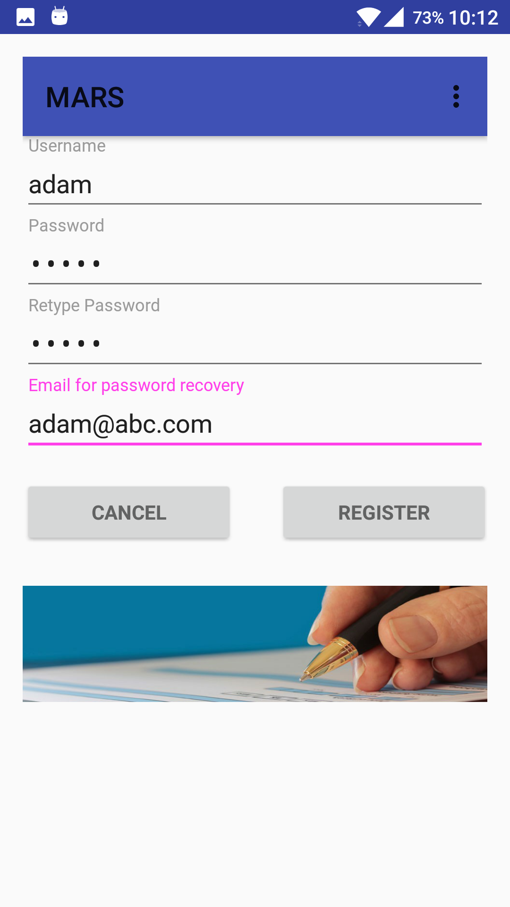

**MainActivity Screen in Android before Increment-2 implementation:**

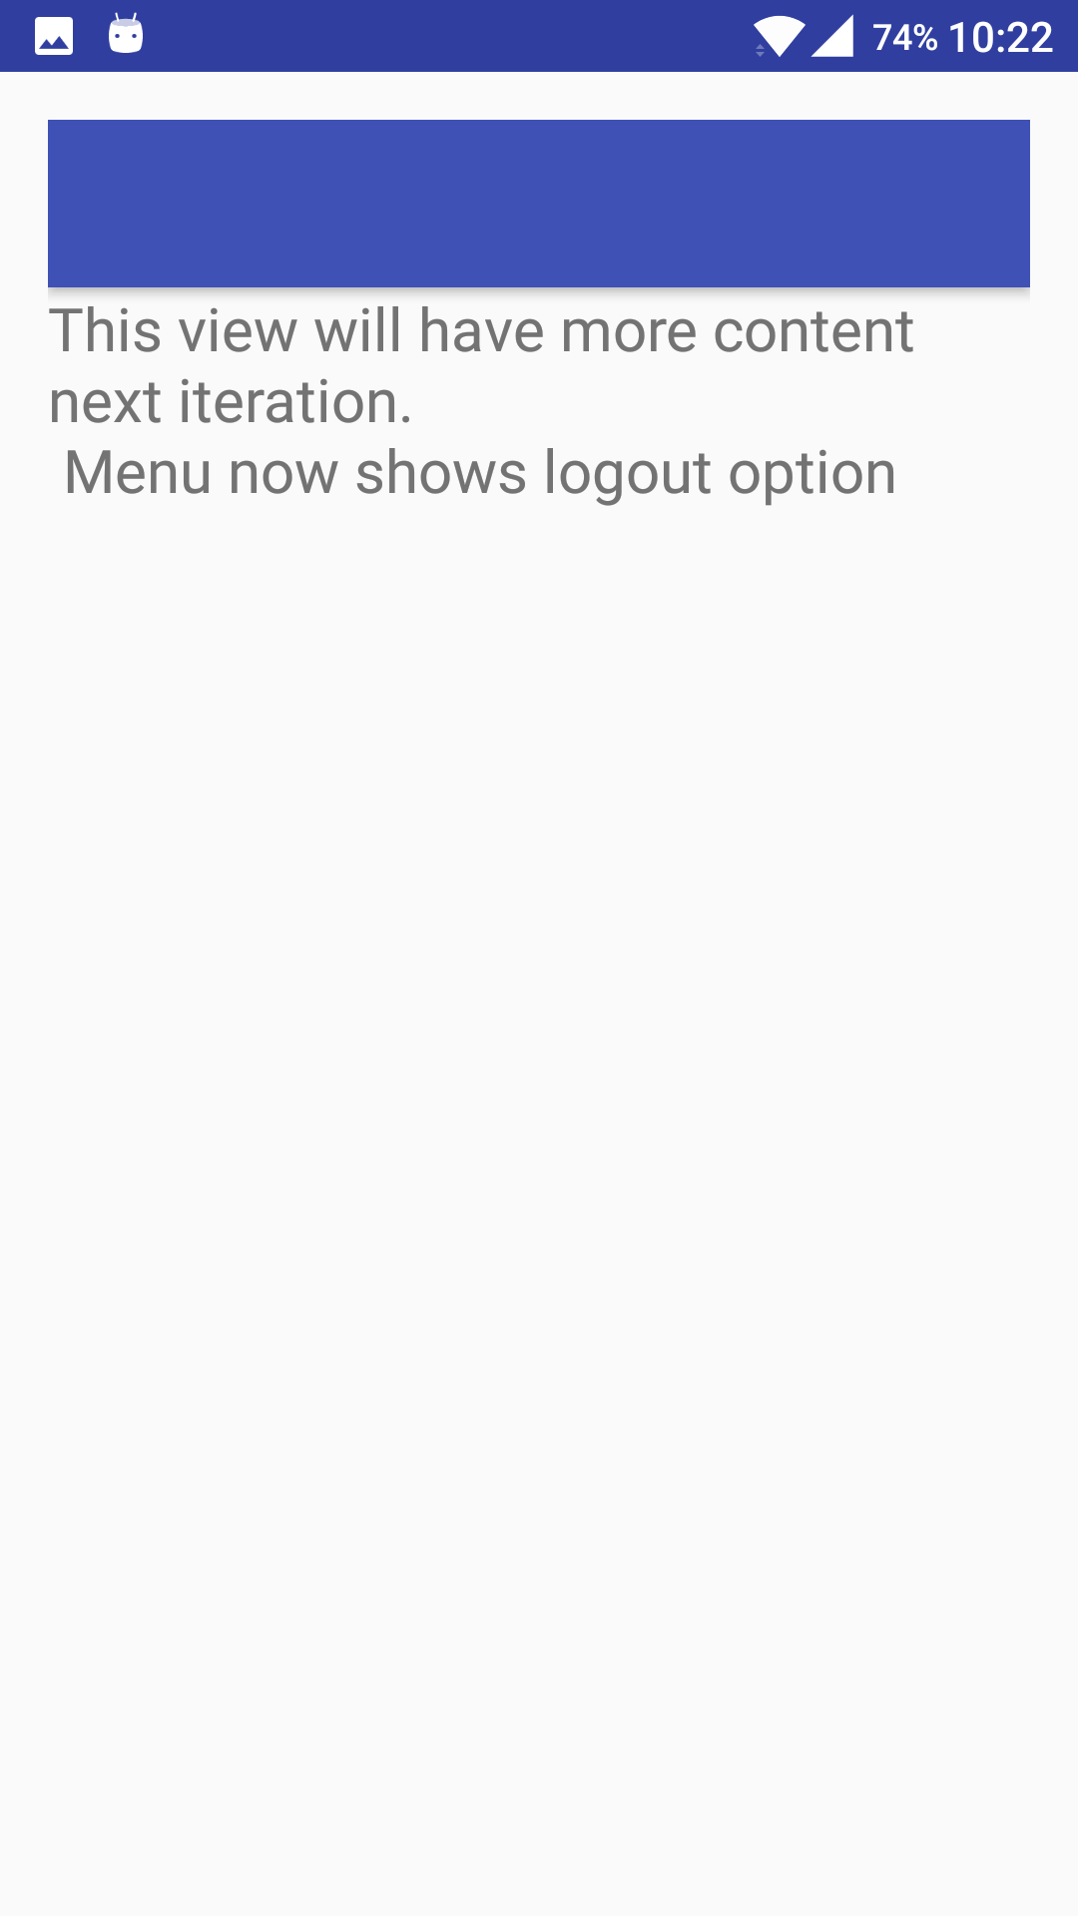

**MainActivity Screen in Android:**

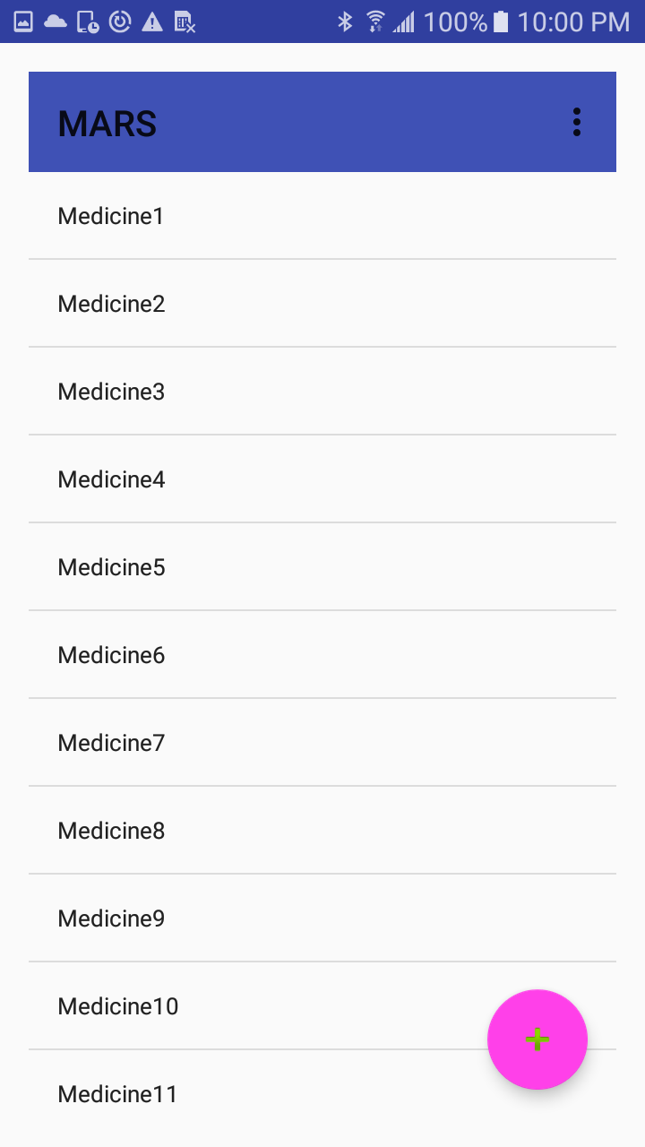

**AddActivity Screen in Android:**

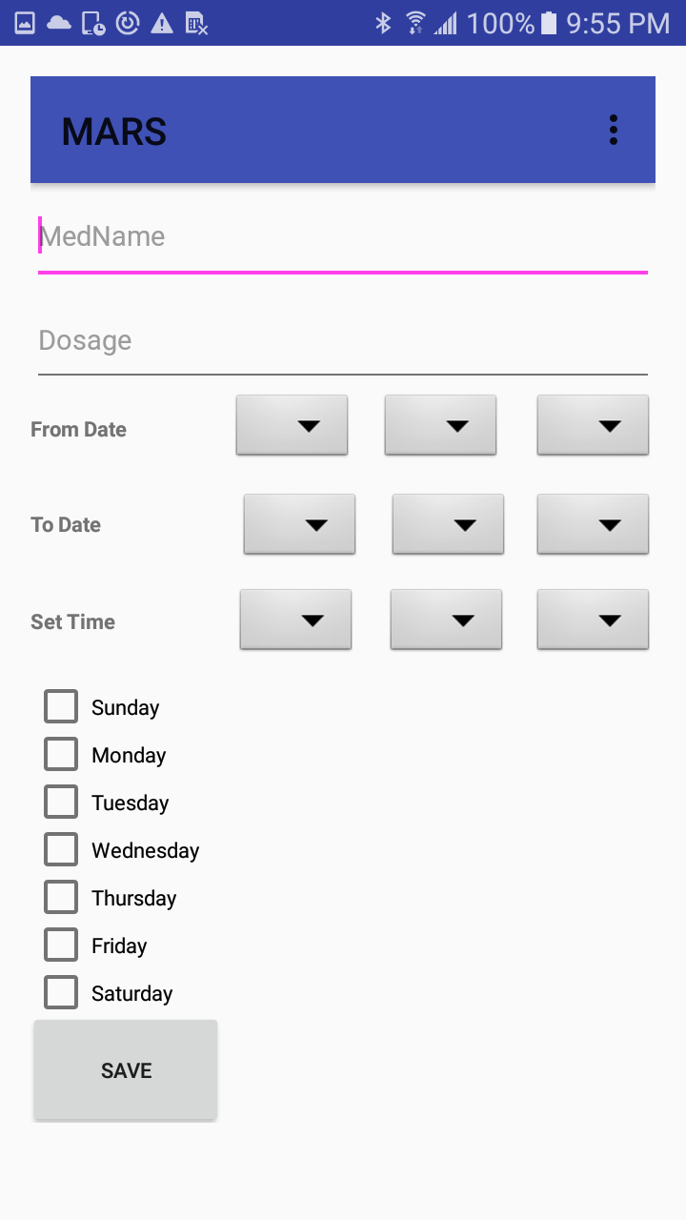

**UpdateActivity Screen in Android:**

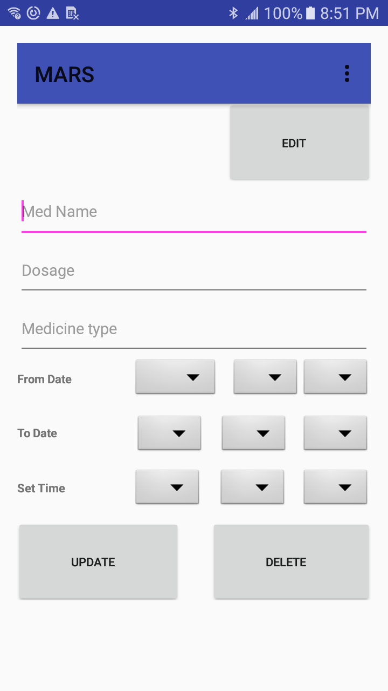

**NotificationActivity Screen in Android:**

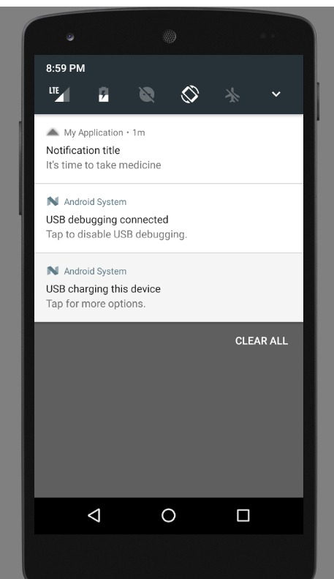

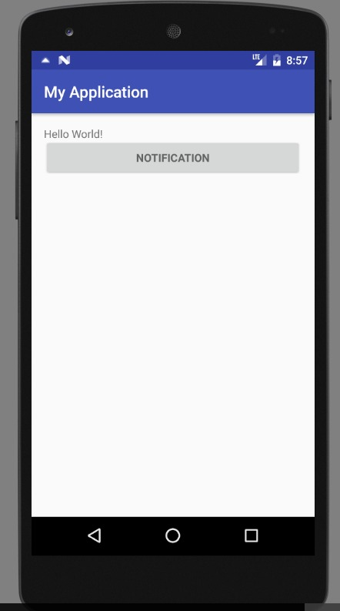

**Third Increment Implementation**

**Contact Accessing Screen in Android:**

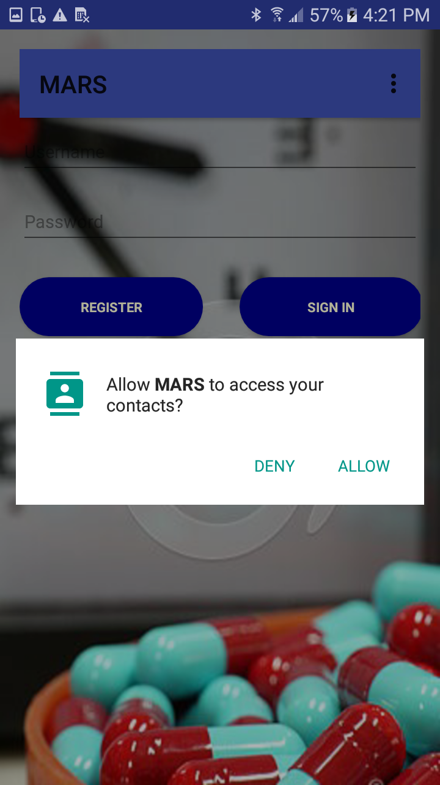

**LoginActivity Screen in Android:**

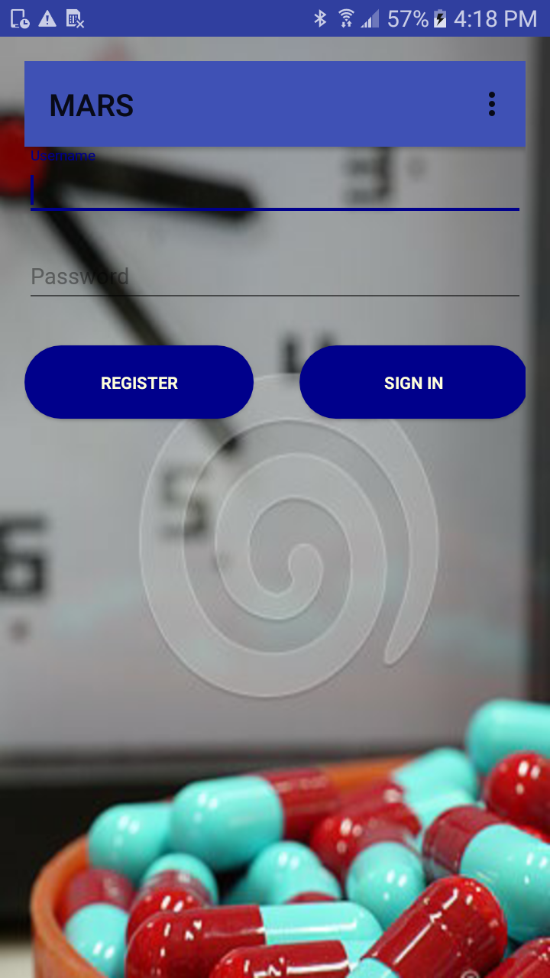

**RegisterActivity Screen in Android:**

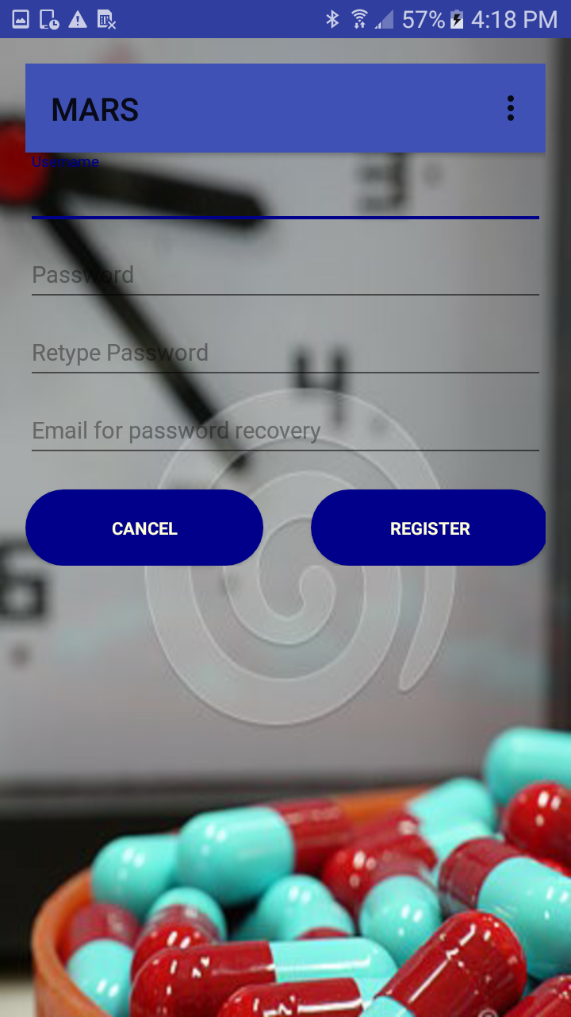

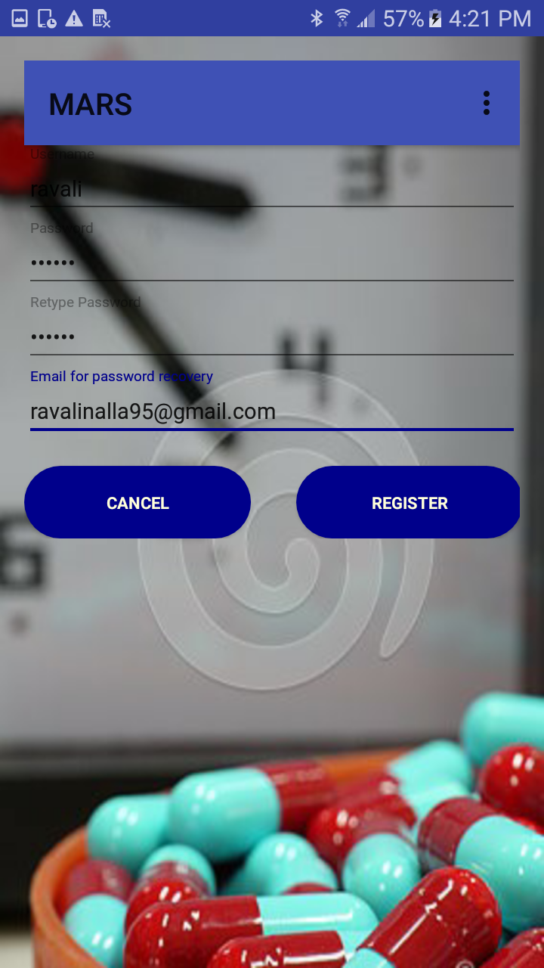

**LoginActivity Screen in Android:**

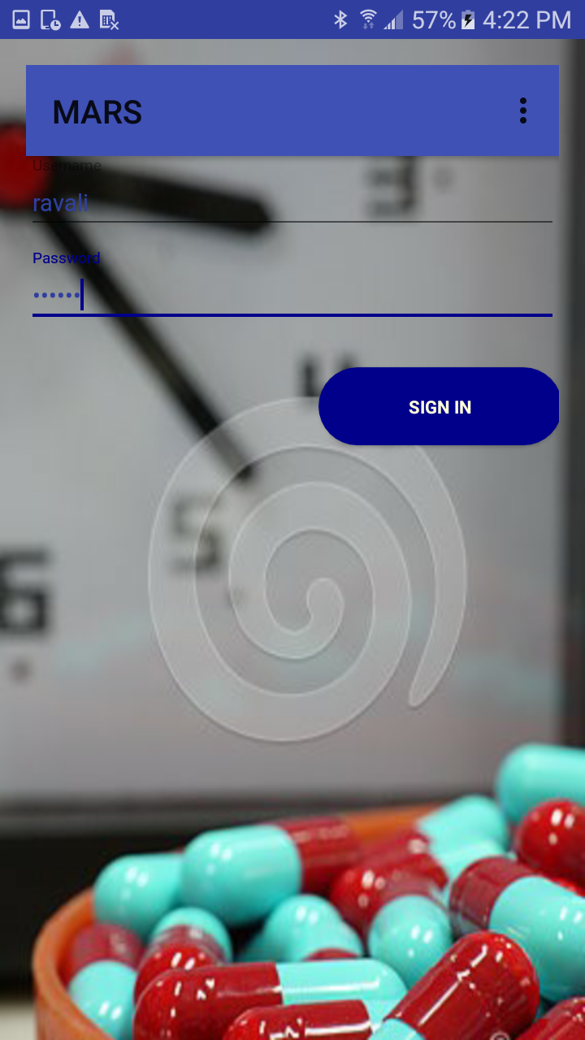

**MainActivity Screen in Android:**

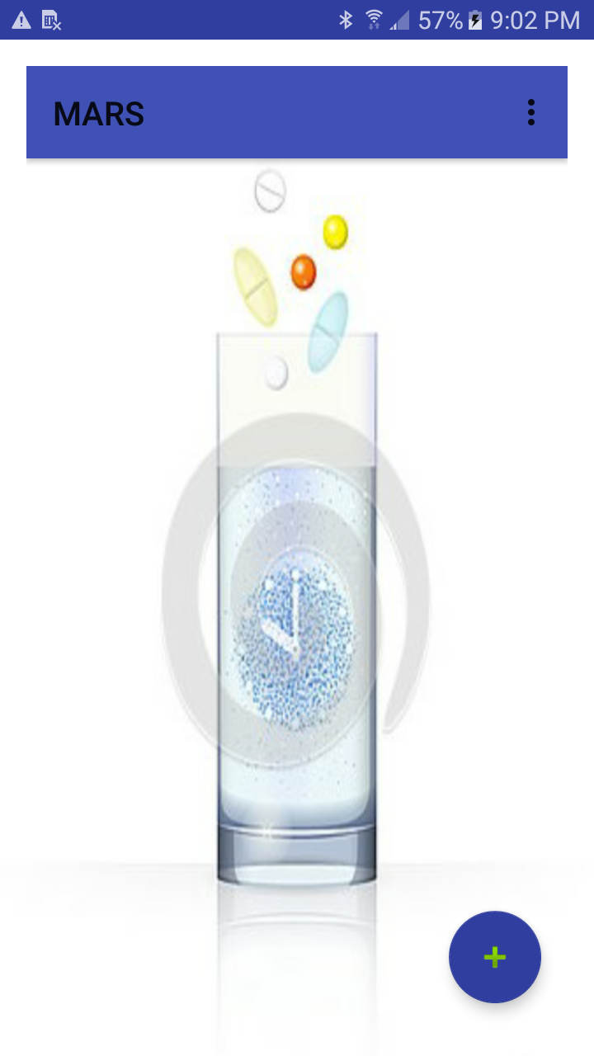

**AddActivity Screen in Android:**

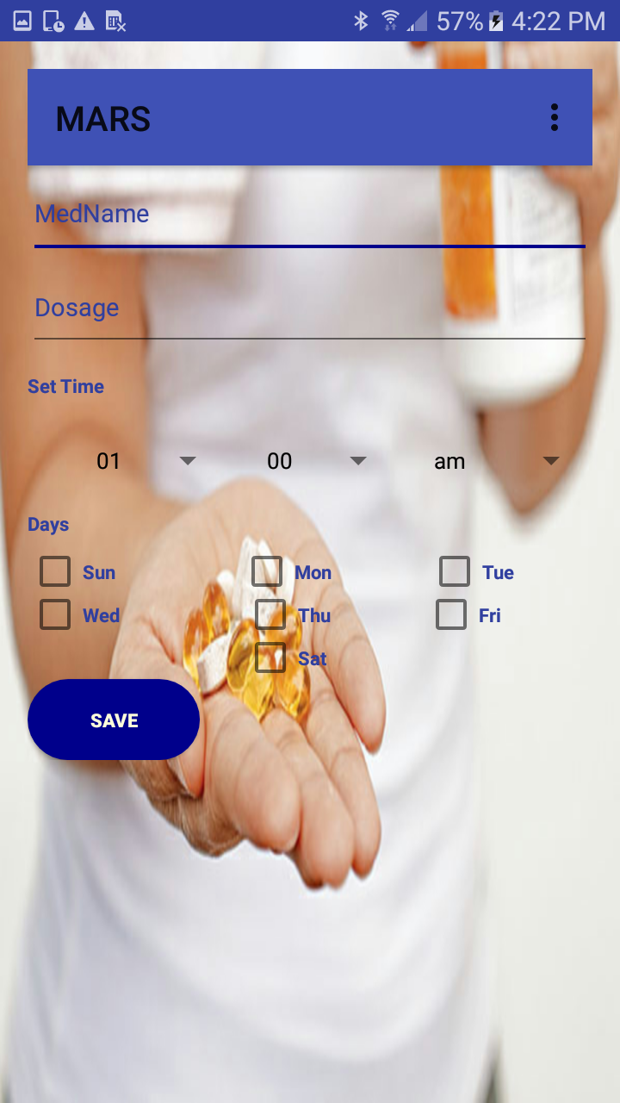

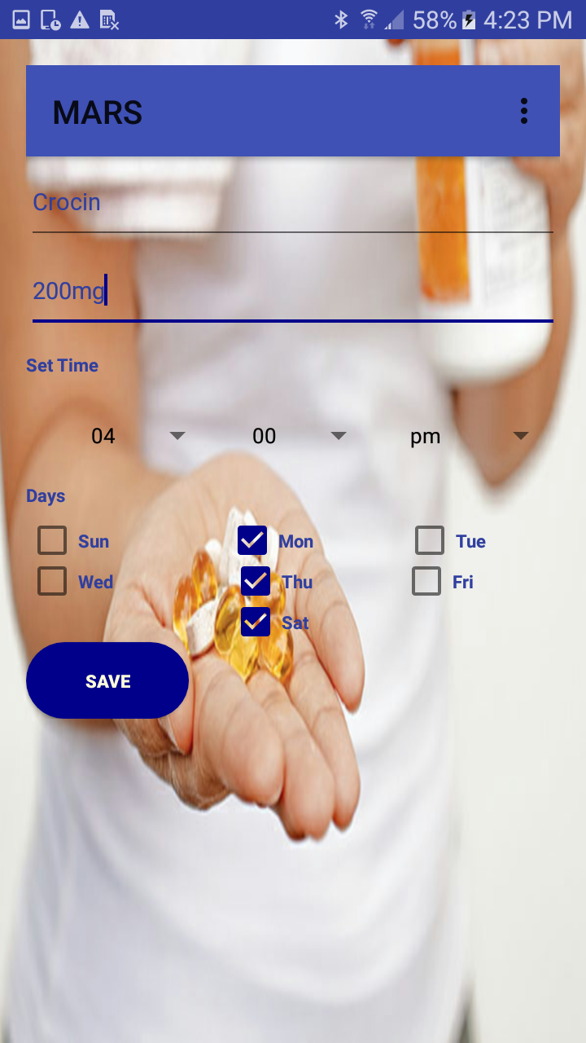

**MainActivity Screen in Android:**

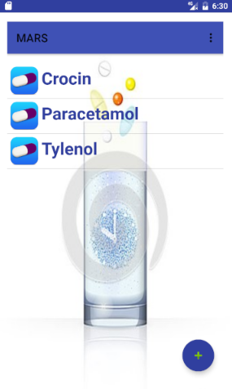

**UpdateActivity Screen in Android:**

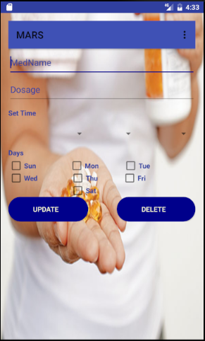

**NotificationActivity Screen in Android:**

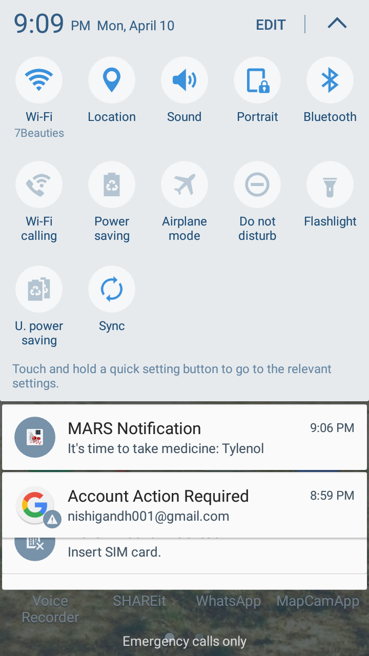

**Existing Services/API**

**MEDICINE REFILL:**

**MEDICINE INFORMATION RETRIEVAL**

## **DailyMed API:**

DailyMed provides high quality information about marketed drugs. This information includes FDA labels. This Web site provides health information providers and the public with a standard, comprehensive, up-to-date, look-up and download resource of medication content and labeling as found in medication package inserts. By using this API we can retrieve information related to a particular medicine.

**URL:** https://www.healthdata.gov/dataset/dailymed

**Testing**

|  |  |  |  |  |
| --- | --- | --- | --- | --- |
| **Sr. No** | **Test Case** | **Description** | **Expected**  **Output** | **Result** |
| 1. | Successful  User Authentication | The user should login with username and password. | Successful Login | Pass |
| 2. | Unsuccessful  User  Authentication | The user logs in with wrong username or password | Login unsuccessful with error-Invalid username or password | Pass |
| 3. | Registration by new user | Admin accepts registration details from the user | Successful registration and transition to Login page | Pass |
| 4. | Invalid Email ID | Invalid Email Id alert. | Error- Enter valid email address | Pass |

**Technologies Used**

**Implementation of Mobile Apps- Technology Used:**

* XML
* CSS
* JavaScript
* Java

**Tools Used:**

* www.Creately.com
* Android SDK

**Project Management**

**Issues:**

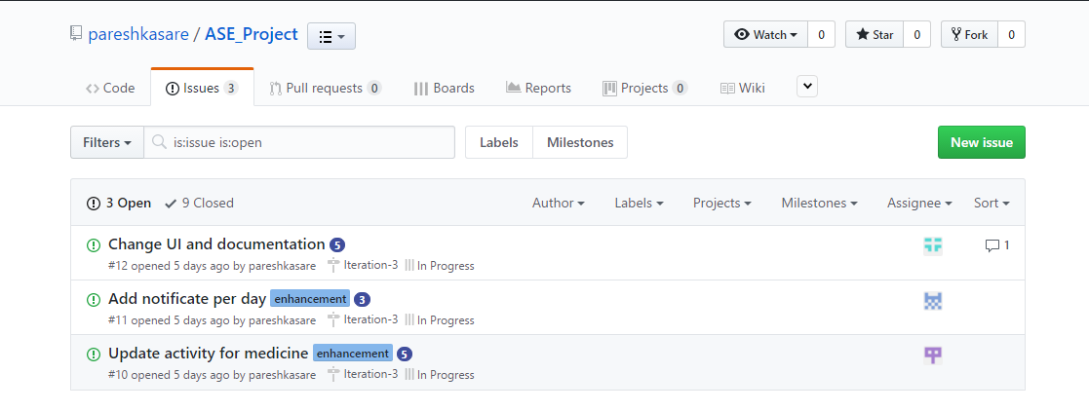

**Bibliography**

[**http://www.fda.gov/Drugs/ResourcesForYou/SpecialFeatures/ucm485545.htm**](http://www.fda.gov/Drugs/ResourcesForYou/SpecialFeatures/ucm485545.htm)

[**http://www.fda.gov/ForConsumers/ConsumerUpdates/ucm164616.htm**](http://www.fda.gov/ForConsumers/ConsumerUpdates/ucm164616.htm)

[**http://www.pfizer.com/health/senior_health/taking_medicines**](http://www.pfizer.com/health/senior_health/taking_medicines)

**https://cloud.google.com/vision/**

**https://www.programmableweb.com/api/walgreens-pharmacy-prescription-refill**

**https://www.healthdata.gov/dataset/dailymed**